**“Open Source Software Laboratory”**

**Code: 4IT475**

Submitted by

**Mr. Adwait Samak (2020BTEIT00021)**

**Email: adwait.samak@walchandsangli.ac.in**

**Mobile: 7757091299**



DEPARTMENT OF INFORMATION TECHNOLOGY

**WALCHAND COLLEGE OF ENGINEERING, SANGLI**

**(An Autonomous Institute)**

**2023-2024**

## **3. Use of Bug Tracking**

Tools:(Trac, Redmine, Phabricator, Youtrack, Mantis, Bugzilla, Donedone (new) etc. : Any One )

Students have to experiment with at last 1 tool/software that they use and their day-to-day life/industry, with their installation, and multiuser configuration on their system, and compare all other tools (free/paid).

In the journal, they have to write information about that tool such as:-

1. The purpose behind that tool/Features
2. Various versions of that tools
3. Installation and Configuration of that tool
4. How to use that tool.
5. Add a sample or choose the FOSS project in the tool and add three bugs and allot to users of the tool.
6. Compare

**Reference:-**

1. [**https://bitnami.com/stacks**](https://bitnami.com/stacks) **(**[**https://bitnami.com/stack/trac**](https://bitnami.com/stack/trac)**)**
2. **Wikipedia List Of Software:-**[**http://en.wikipedia.org/wiki/List_of_free_and_open**](http://en.wikipedia.org/wiki/List_of_free_and_open-source_software_packages)**-** [**source_software_package**](http://en.wikipedia.org/wiki/List_of_free_and_open-source_software_packages)**s**
3. **Open Source Software Mega List:-** [**http://www.datamation.com/open-source/open**](http://www.datamation.com/open-source/open-source-software-the-mega-list-1.html)**-**[**source-software-the-mega-list-1.htm**](http://www.datamation.com/open-source/open-source-software-the-mega-list-1.html)**l**

**Experiment 3**

**Title-** Use of Bug Tracking

**Problem Statement-** To install and demonstrate the use of various open-source software‟s that are used in day to day life of software engineering.

**Objectives-** Students have to study at least 3 various open source tools/software that they use and their day-to-day life, with their installation and configuration on their system

**Theory-** MantisBT is a web-based bug-tracking system that was first made available to the public in November 2000. Over time it has matured and gained a lot of popularity, and now it has become one of the most popular open-source bug/issue tracking systems. MantisBT is developed in PHP, with support for multiple database backends including MySQL, MS SQL, and PostgreSQL.

MantisBT, as a PHP script, can run on any operating system that is supported by PHP and has support for one of the DBMSes that are supported. MantisBT is known to run fine on Windows, Linux, macOS, and a variety of Unix operating systems.

MantisBT is available in several Linux distributions including Debian, Ubuntu, Fedora, Gentoo, Frugalware, and others.

**Features Of Mantis**-

* Project, sub-project, and category support.
* User-based security.
* Advanced search tools.
* Reporting and graphing.
* E-mail and RSS feed support.
* Customizable issue pages and workflow.
* Revision control integration.
* Document management.

**System Requirements**

**Server Hardware Requirements**

MantisBT has modest hardware requirements. It requires a computer that is able to run the server software

1. Server type- The server can be a shared public web server or a dedicated co-located box.
2. CPU and Memory- As for any web application, you should size your server based on the traffic on the site.
3. Disk- The application code is less than 50 MB. The amount of disk space required for the database will vary depending on the RDBMS and the volume of data, the main driving factor being the expected number and size of attachments.

**Server Software Requirements**

All of the required software is free for commercial and non-commercial use (open source). Please refer to the table in Section 2.2.2.1, “Versions compatibility table” for minimum and recommended versions.

1. Operating System- MantisBT runs on Windows, macOS, Linux, Solaris, the BSDs, and just about anything that supports the required server software.
2. Web Server- MantisBT is mainly tested with Microsoft IIS and Apache. However, it is expected to work with any recent web server software.
3. File Extensions: MantisBT uses only .php files. If your web server is configured for other extensions (e.g. .PHP3, PHTML) then you will have to request the administrator to add support for . PHP files. This should be a trivial modification. Further details can be found in the PHP documentation
4. PHP- The web server must support PHP. It can be installed as CGI or any other integration technology.
5. PHP extensions- MantisBT is designed to work in as many environments as possible. Hence the required extensions are minimal and many of them are optional affecting only one feature.
6. Mandatory extensions- The extension for the RDBMS being used ( mysqli, pgsql, oci8, sqlsrv )mbstring - Required for Unicode (UTF-8) support. date, hash, json, pcre, Reflection, session - Required to run MantisBT in general.
7. Optional extensions
   1. Curl - required for the Twitter integration feature
   2. GD - required for the captcha feature
   3. Fileinfo - required for file attachments and most of the plugins Without this extension, file attachment previews and downloads do not work as MantisBT won't be able to send the Content-Type header to a browser requesting an attachment.
   4. LDAP - required for LDAP or Active Directory authentication (see Section 8.2, “LDAP and Microsoft Active Directory”).
   5. zlib - required to enable output compression

**Installation Requirements**

MantisBT is highly customizable through the web interface and configuration files. Configuration options can be set globally as well as customized for a specific project or user (except for options listed in $g_global_settings.

Configuration options can be set in config_inc.php and in the database (using the various managed pages). Values stored in the database take precedence over values defined in config_inc.php.

To determine which value to use, MantisBT follows the list below, sequentially searching for the specified configuration option until a match is found.

* database: current user, current project
* database: current user, all projects
* database: all users, current project
* database: all users, all projects
* config_inc.php
* config_defaults_inc.php

Base Database settings

These settings are required for the system to work, and are typically set when installing MantisBT. They should be provided to you by your system administrator or your hosting company.

*$g_hostname*

Host name or connection string for Database server. The default value is localhost. For MySql, this should be hostname or hostname:port (e.g. localhost:3306).

*$g_db_username*

User name to use for connecting to the database. The user needs to have read/write access to the MantisBT database. The default user name is "root".

*$g_db_password*

Password for the specified user name. The default password is empty.

*$g_database_name*

Name of database that contains MantisBT tables. The default name is 'bugtracker'.

*$g_db_type*

The supported database types- MySQL, PostgreSQL, MySQL Server,Oracle

**How to Use Install Tool**

* The script checks basic parameters for the web server
* Provide required information for the installation
* database type
* database server hostname
* user and password
* Required privileges: SELECT, INSERT, UPDATE, and DELETE
* high-privileged database account
* Additional privileges required: INDEX, CREATE, ALTER, and DROP
* If this account is not specified, the database user will be used.
* Click the Install/Upgrade Database button
* The script creates the database and tables.
* The default Administrator user account is created at this stage, to allow the initial login and setup of MantisBT.
* The script attempts to write a basic config_inc.php file to define the database connection parameters.
* This operation may fail if the web server's user account does not have write permissions to the directory (which is recommended for obvious security reasons). In this case, you will have to manually create the file and copy/paste the contents from the page.
* The script performs post-installation checks on the system.
* Review and correct any errors.

**How to Use Mantis Bug Tracker?**

Step 1: Navigate to the Manage Projects sections by clicking on the Manage tab present on the left panel of the screen.

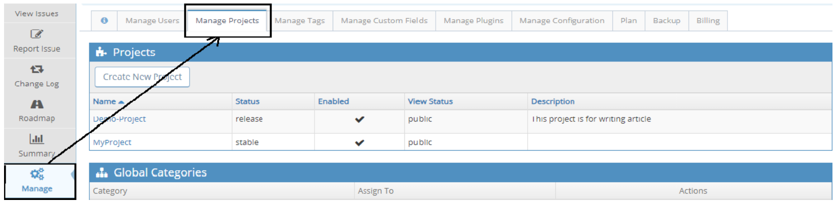

Step 2: Add the Project details by clicking on the Create project button. In the Project details, fill the following fields:

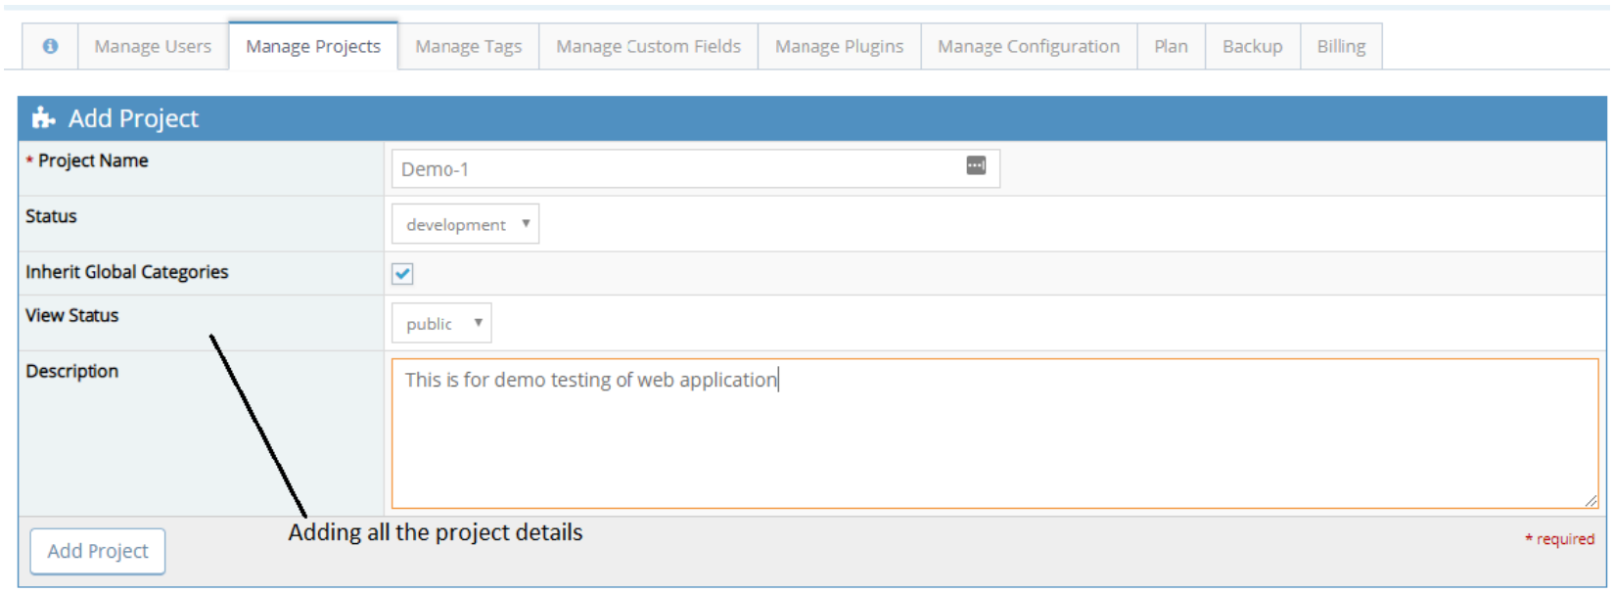

Step 3: After entering all the project details, click on the Add Project button present at the bottom to complete the project creation. We can see the above newly added project under the Manage -> Manage Projects section.

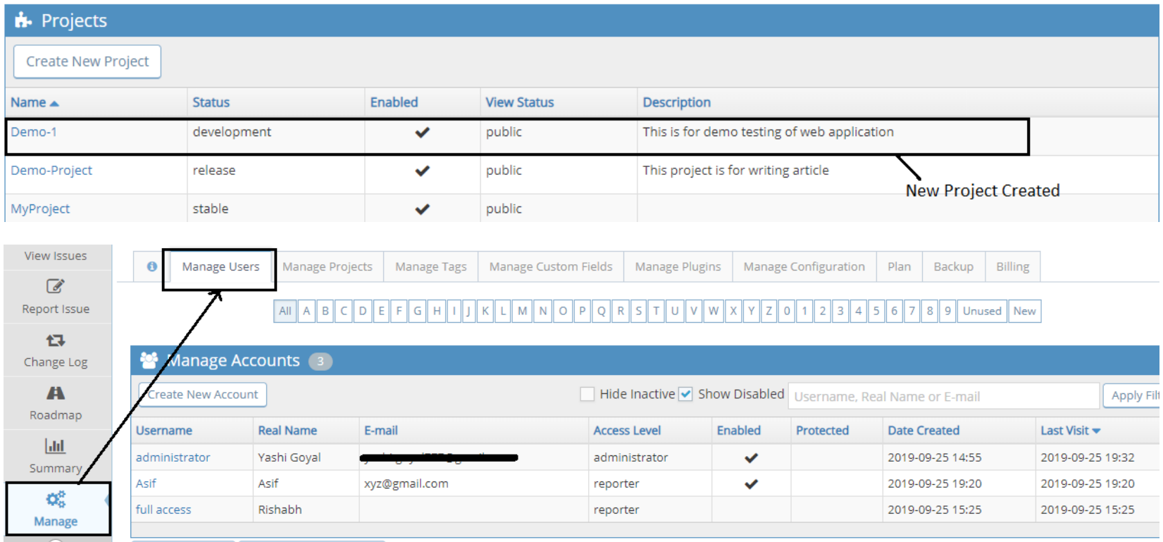

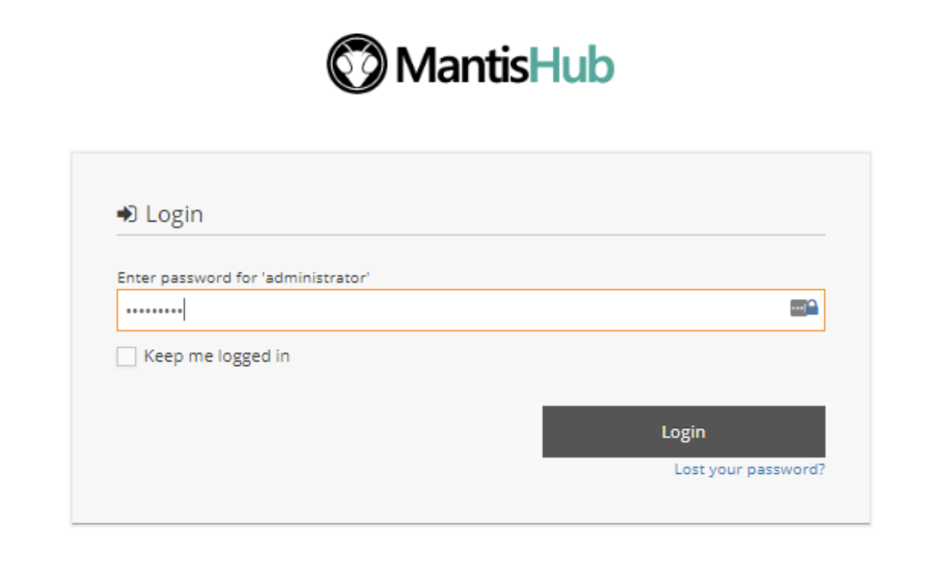

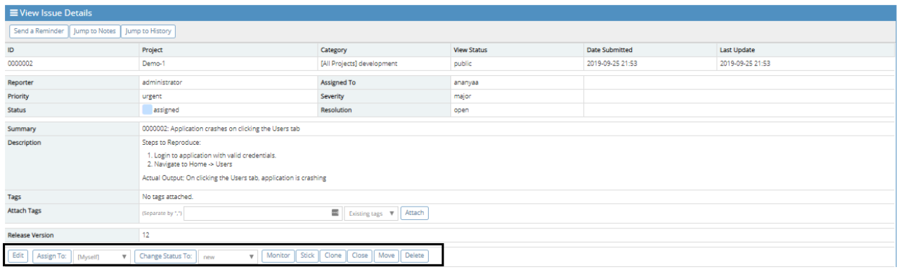

Step 4: Now, more details can be added to the above-created issue, like changing the status. Consider a case in which the tester mistakenly reported an issue that is a duplicate of the already present issue; he/she can mark Close or Delete whatever they feel like according to the situation.

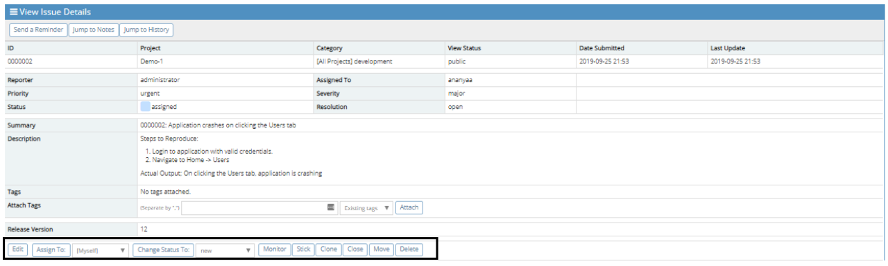

Step 5: ‘Add Note’ section is also displayed to the user if the reporter or the assigned person wants to add something regarding the above issue

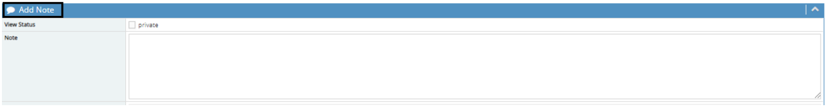

Step 6: ‘Issue History’ section is displayed in order to check the history of the above issue. It shows every single detail of the task which is done by any of the people on the issue.

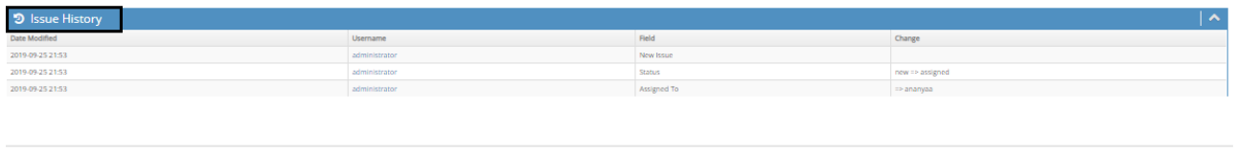

Step 7: All the created issue by a particular user is displayed on the timeline of the user with all the details, User can view the timeline by clicking on the ‘My View’ tab.

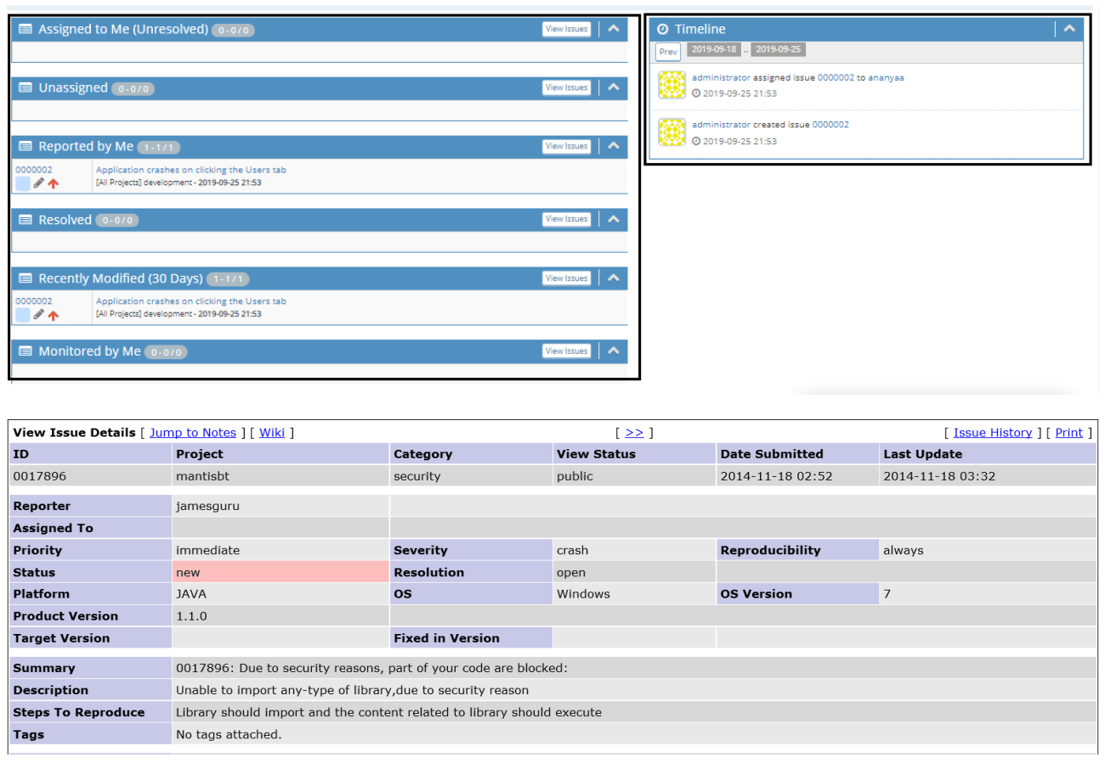

**Various versions of MantisBT**

MantisBT 2.25.5

Security and maintenance release fixing vulnerabilities with SVG files attachments (CVE-2022-33910), which are now disabled by default; instances with a custom $g_disallowed_files should add svg to the list. Support for PHP 5.6 has been restored, fixing the regression introduced in 2.25.4.

MantisBT 2.25.4

Maintenance release fixing a couple of regressions introduced in 2.25.3, loading a JavaScript library from CDN and initializing the path on PHP 5.6.

MantisBT 2.25.3

This security and maintenance release fixes vulnerabilities in CSV Export (CVE2021-43257) and Plugins management pages (CVE-2022-26144), as well as in bundled libraries guzzlehttp/psr7 (CVE-2022-24775) and moment.js (CVE-2022- 24785). It also addresses several PHP 8.1 compatibility issues.

**Compare Tools**

JIRA Vs Mantis

JIRA is the tracker for teams planning & building great products. Millions choose JIRA to capture & organize issues, assign work, & follow team activity.

Whereas,

MantisBT is an open source, bug and issue tracking software written in PHP, and under GNU protocol, facilitating the collaboration of team members and clients

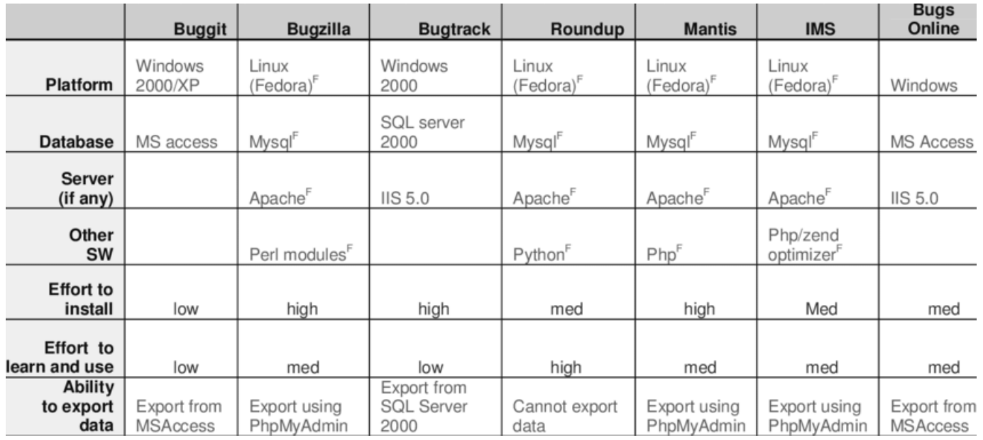

**Conclusion**

Learned how to install and demonstrate the use of various open source software‟s like bug tracking tools (Phabricator, mantis, etc.)that used in day to day life of software engineering.

**Reference**

1. <https://www.mantisbt.org/>
2. <https://www.mantisbt.org/bugs/my_view_page.php>